**CLINIC MANAGEMENT SYSTEM**

**B.Tech .SEMINAR REPORT**

Submitted to Dr. Babasaheb Ambedkar Technological University in Lonere in Partial Fulfillment of the

Requirements for the Degree of BACHELOR OF TECHNOLOGY in

Computer Engineering.

By

|  |
| --- |
| **Puja Vilas Bonde** |
| **Harshvardhan Sham Bhavsar** |
| **Kirti Nitin Mahajan** |

Guide: Mrs.R.D.Bharambe



**DEPARTMENT OFCOMPUTER ENGINEERING**

**J.T. MAHAJAN COLLEGE OF ENGINEERING, FAIZPUR**

**JAN 2023**

# PREFACE

We have made this report file on the topic**Clinic Management System**; We have tried my best to elucidate all the relevant detail to the topic to be included in the report. While in the beginning we have tried to give a general view about this topic.

Our efforts and wholehearted co-corporation of each and everyone has ended on a successful note. We express my sincere gratitude to who assisting us throughout the preparation of this topic. We thank him for providing us the reinforcement, confidence and most importantly the track for the topic whenever we needed it.

## Index

## Content Page No.

1. Introduction ……………………………………………………1

## Needs …………………………………………………………..2

1. Objective ………………………………………………………3
2. Scope of project ……………………………………………….4
3. Technology proposed for project ……………………………...5
4. Feasibility Study……………………………………………….6
5. Case Tools……………………………………………………..7
6. Testing tools…………………………………………………..10

9.1 Black Box Testing………………………………………...11

9.2 White Box Testing………………………………………...12

9.3 GUI Testing……………………………………………….12

1. Onscreen Views.………………………………………………13
2. Limitation……………………………………………………..20
3. Conclusion …………………………………………………...21
4. References……………………………………………………22

**J.T. MAHAJAN COLLEGE OF ENGINEERING, FAIZPUR**

**Department of Computer Engineering**

**CERTIFICATE**



This is to certify that the project entitled, **“ Clinic Management System ”**, which is being submitted herewith for the award of B.E. is the result of the work completed by **Puja Vilas Bonde, Harshvardhan Sham Bhavsar, Kirti Nitin Mahajan.** under my supervision and guidance within the four walls of the institute and the same has not been submitted elsewhere for the award of any degree.

Prof. R.D.Bharambe Dr.K.S.Bhagat

Guide Department of Computer Engg.

Examiner Dr.R.D.Patil

Principal

J.T.M.C.O.E,Faizpur

**DECLARATION**

We hereby declare that the project entitled, **“Clinic Management System”** was carried out and written by me/us under the guidance of Prof. R.D.Bharambe, Department of Computer Engineering. This work has not been previously formed the basis for the award of any degree nor has been submitted elsewhere for the award of any degree.

Place: Faizpur

Date:

**ACKNOLEDGEMENT**

We would like to express my special thanks of gratitude to our assistant professor guide **Prof. R.D.Bharambe** and our principal ( Dr.R.D.Patil ) who gave us the golden opportunity to do this project on the topic **Clinic Management System**. It helped us in doing a lot of Research and we came to know about a lot of things related to this topic.

Finally, we would also like to thank my parents and friends who helped me a lot in finalizing this project within the limited time frame.

|  |
| --- |
| **Puja Vilas Bonde** |
| **Harshvardhan Sham Bhavsar** |
| **Kirti Nitin Mahajan** |

## Abstract of Clinic Management System

A **Clinic Management System Project in Django** is a full-stack Django web application that offers a clean, descriptive, and interactive user interface for viewing and registering patients and for managing doctors and patients.

Moving on, It has responsive features and tabs for patients, health histories, patients visits, prescriptions, clinic staff, suppliers, feedbacks, drug records, and appointments.

However, This is a role-based module in which the admin can perform any operation on the data. The Django hospital management system is a web framework for patient and doctor.

## List of Figure

|  |  |  |
| --- | --- | --- |
| Sr No. | Figure Name | Page No. |
| 1. | Data Flow Diagram | 9 |
| 2. | Activity Daigram | 10 |
| 3. | Home Page | 13 |
| 4. | About Us Page | 13 |
| 5. | Contact Page | 14 |
| 6. | Admin Login Page | 14 |
| 7. | Admin / Dashboard Page | 15 |
| 8. | Add / View Doctor Page | 15 |
| 9. | Add / View Patients Page | 16 |
| 10. | Add / View Appointment Page | 17 |
| 11. | Unread / Read Queries Page | 18 |

## Introduction

The project Clinic Management system includes registration of patients, storing their details into the system, and also computerized billing. The software has the facility to give a unique id for every patient and stores the details of every patient and the staff automatically. It includes a search facility to know the current status of each Patient Appointment. User can search availability of a doctor and the details of a patient using the id.

The Hospital Management System can be entered using a username and password. It is accessible either by an administrator or receptionist. Only they can add data into the database. The data can be retrieved easily. The interface is very user-friendly. The data are well protected for personal use and makes the data processing very fast.

Hospital Management System is powerful, flexible, and easy to use and is designed and developed to deliver real conceivable benefits to hospitals. Clinic Management System is designed for small OPD Clinics, to cover a wide range of Clinic administration and management processes. It is an integrated end-to-end Clinic Management System that provides relevant information across the hospital to support effective decision making for patient care, Clinic administration and critical financial accounting, in a seamless flow.

Clinic Management System is a software product suite designed to improve the quality and management of Clinic management in the areas of clinical process analysis and activity-based costing. Clinic Management System enables you to develop your organization and improve its effectiveness and quality of work. Managing the key processes efficiently is critical to the success of the Clinic helps you manage your processes.

**1**

**NEED**

* Helps in recording Patients Data with Unique Patient ID
* Reduces Administrative works.
* Saves time & improves employee.
* Reduces Wastage of Paper work.
* Provides a fast and efficient service.
* Increase clinic & patient satisfaction.
* Maintains record of the Patients OPD & Appointments.
* Easy to maintain the records of various Speciality Doctors.
* Helps in provide good services.

**2**

**OBJECTIVES**

**Objectives of project:**

The main objective of the **Clinic Management System** is to manage the details of Doctors, Patient, OPD Visits, Queries, Appointments, etc,. It manages all the information about Doctors, Patient, OPD Visits, Queries, Appointments, etc,. The project is totally built at administrative end and thus only the administrator is guaranteed the access.

Functionalities provided by Clinic Management System are as follows:

1. Define Clinic
2. Recording information about the Patients that come.
3. Generating Patient unique ID.
4. Recording information related to diagnosis given to Patients.
5. Keeping record of the Immunization provided to children/patients.
6. Keeping information about various diseases and medicines available to cure them.

These are the various jobs that need to be done in a Clinic by the operational staff and Doctors. All these works are done on papers.

**3**

**SCOPE OF PROJECT**

The scope of the **Clinic Management System** is as follows:

1. Information about Patients is done by just writing the Patients name, age and gender. Whenever the Patient comes up his information is stored freshly.
2. Bills are generated by recording price for each facility provided to Patient on a separate sheet and at last they all are summed up.
3. Diagnosis information to patients is generally recorded on the document, which contains Patient information. It is destroyed after some time period to decrease the paper load in the office.
4. Immunization records of children are maintained in pre-formatted sheets, which are kept in a file.
5. Information about various diseases is not kept as any document. Doctors themselves do this job by remembering various medicines.

All this work is done manually by the receptionist and other operational staff and lot of papers are needed to be handled and taken care of. Doctors have to remember various medicines available for diagnosis and sometimes miss better alternatives as they can’t remember them at that time.

**4**

**TECHNOLOGY PROPOSED FOR PROJECT**

**HARDWARE AND SOFTWARE REQUIREMENT**

The most common set of requirements defined by any operating system or software application is the physical computer resources, also known as hardware. A hardware requirements list is often accompanied by a hardware compatibility list (HCL), especially in case of operating systems. An HCL lists tested, compatibility and sometimes incompatible hardware devices for a particular operating system or application. The following sub-sections discuss the various aspects of hardware requirements.

**HARDWARE REQUIREMENTS FOR PRESENT PROJECT**:

PROCESSOR : Intel dual Core ,i3

RAM : 1 GB

HARD DISK : 80 GB

**SOFTWARE REQUIREMENTS:**

Software Requirements deal with defining software resource requirements and pre-requisites that need to be installed on a computer to provide optimal functioning of an application. These requirements or pre-requisites are generally not included in the software installation package and need to be installed separately before the software is installed.

**SOFTWARE REQUIREMENTS FOR PRESENT PROJECT:**

OPERATING SYSTEM : Windows 7/ XP/8

FRONT END : Html,css,java script.

SERVER SIDE SCRIPT : Php

DATABASE : Mysql

**5**

**FEASIBILITY STUDY**

At the time of the development we have gone through the following phases:

**Recognition of need (Requirement specification):**

         It refers to the organization’s needs, requirements and expectations from the project to be developed. After recognizing the organization’s need, it has been taken in writing and then a rough idea of the system/project has been given to the firm.

1. **Feasibility Study:**

 It is always essential to evaluate the various aspects before we develop the project. Evaluation should always justify the cost and benefits ratio. Economic, social and technical feasibility of project is analyzed.

1. **Data Collection:**

Here comes an important aspect of project development i.e. data collection. For this to accomplish, we observe registers, bills, invoices and order orders

1. **Data Normalization:**

Normalization means allowing only a single value in a table’s row and column intersection. For this, entities are identified from the data collected and normalized tables with appropriate relationship and minimized redundancy are designed.

1. **System Design:**

This step includes drawing of different diagrams such as DFD and ERD. It includes database design, form design etc.

1. **Coding:**

It is the most critical stage among all the stages of development.  It has taken approximately seven days to complete. It involves giving functioning to data entry forms with the help of action, validation, calculations and linking of different data entry forms.

1. **Testing:**

It involves testing of the working of the project.

1. **Implementation :**

This involves deployment of project to client side.

1. **User training:**

It is one day activity involving training to the user to operate the project.

**6**

**CASE TOOLS**

It is always essential to evaluate the various aspects before we develop a system. Evaluation should always justify the cost and benefits ratio. If it is found that benefits are less as compare to the cost of project, then it is better to avoid going in for computerization.

The key consideration involved in the Feasibility analysis is:

**1. Technical Feasibility.**

**2. Economical Feasibility.**

**3. Social Feasibility.**

**1. Technical Feasibility:**

This study is carried out to check the technical feasibility, that is,the technical requirements of the system. Any system developed must not have a high demand on the available available technical resources. This will lead to high demands being placed on the client. The developed system must have a modest requirement, as only minimal or null changes for the implementing this system.

1. **Economical feasibility**:

This study is carried out to check the economic impact will have on the system will have on the organization. The amount of fund that the company can pour into the research and development of the system is limited. The expenditures must be justified. Thus the developed system as well within the budget and this was achieved because most of the technologies used are freely available. Only the customised products have to be purchased.

1. **Social Feasibility:**

The aspect of study is to check the level of acceptance of the system by the user. This includes the process of training the user to use the system efficiently. The user must not feel threatened by the system, instead must accept it as a necessity. The level of acceptance by the users solely depends on the methods that are employed to educate the user about the system and to make him familiar with it. His level of confidence must be raised so that he is also able to make some constructive criticism, which is welcomed, as he is the final user of the system.

**7**

**Data Flow Diagram (DFD)**

* Data flow diagram is graphical tool which is used to describe and analyze the movement of data through a system. They focus on the data flowing into the system, between processes and in & out of data stores.
* DFD is a graphical technique that detects information flow and transformation that are applied as data move from input and output.
* DFD is a central tool and the basis from which other components are developed.
* DFD provides mechanism for a final modeling as well as information flow modeling.
* DFD has very simple notation which are easily understood by the users & those who involved in the system.

**Symbol used for DFD**

**Symbol Meaning**

External Entity as source

Destination.

Process or Function.

Indicates direction of data flow

File Storage i.e. data is

Stored for use by one or more.

Stored for use by one or more.

**8**

**Data Flow Diagram**

**9**

**Activity Diagram**

**10**

**TESTING TOOLS**

Testing is important from the point of view of accurate functioning of the project. There are many testing measures and tools available to test a project.

Basic tools used to test this project are:

1. Black Box Testing.
2. White Box Testing
3. GUI Testing

**1. Black Box Testing:**

It is a method of software testing that tests the functionality of an application as opposed to its internal structures or workings. Specific knowledge of the application’s code/internal structure and programming language in general is not required. The tester is only aware of what the software is supposed to do, but not how i.e. when he enters a certain input, he gets certain output; without being aware of how the output was produced. Tests cases are build around specifications and requirements, i.e., what the application is supposed to do. It uses external descriptions of the software, including specifications, requirements and designs to derive test cases. These test designer select valid and invalid inputs and determine the correct output. There is knowledge of the test object’s internal structure.

                This method of test can be applied to all levels of software testing: Unit, Integration, System and Acceptance. It typically comprises most if not all testing at higher levels, but can also dominate unit testing as well.

**The advantages of this type of testing include:**

* The test is unbiased because the designer and the tester are independent of each other.
* The tester does not need knowledge of any specific programming languages.
* The test is done from the point of view of the user, not designer.

**The disadvantages of this type of testing include:**

* The case can be redundant if the software designer has already run a test case.
* The test cases are difficult to design.

**11**

**2. White Box Testing:**

White box testing is a method of testing software that tests internal structures or workings of an application, as opposed to its functionality. In white-box testing an internal perspective of the system, as well as programming skills, are required and used to design the test cases. The tester chooses input to exercise paths through the code and determine the appropriate outputs. While white-box testing can be applied at the unit, integration and system levels of the software testing process, it is usually done at unit level. It can test paths within a unit, paths between units during integration, and between subsystems during a system level test. Though this method of test design can uncover many errors or problems, it might not detect unimplemented parts of the specification or missing requirements.

**White-Box test design techniques include:**

* Control flow Testing
* Data flow Testing
* Branch Testing
* Path Testing

For a complete software examination, both white box and black box tests are required.

**3. Graphical User Interface Testing:**

It is the process of testing a product’s graphical user interface to ensure it meets its written specifications. This is normally done through the use of a variety of test cases. It checks only the user friendliness. The creation of the user interface is less time consuming for the user but more complex for the programmer. It must be tested for its sole purpose.

**This test must be carried out to ensure:**

* Windows open properly.
* All data contents are properly addressable.
* All the graphical elements are available and displayed.

Multiple or incorrect mouse click do not produce side effects

**12**

**Onscreen Views**

**Home Page**

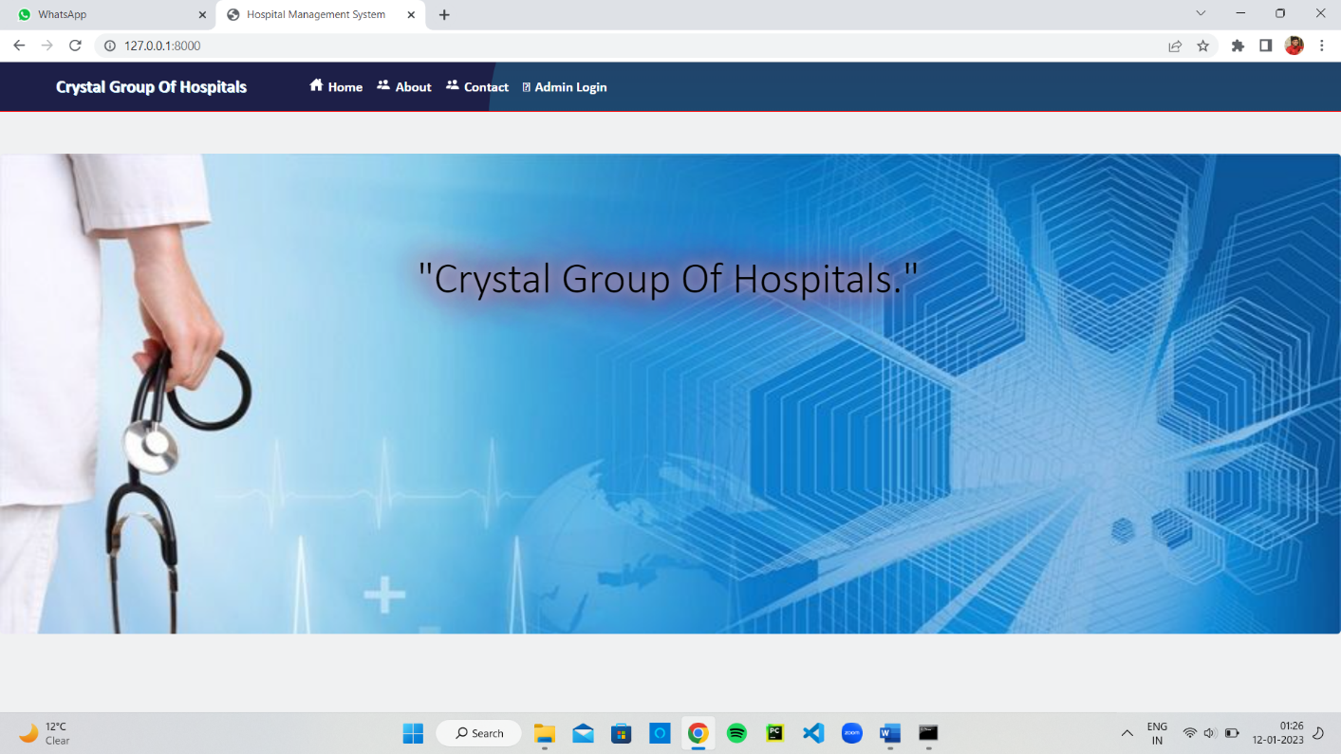

**About Us Page**

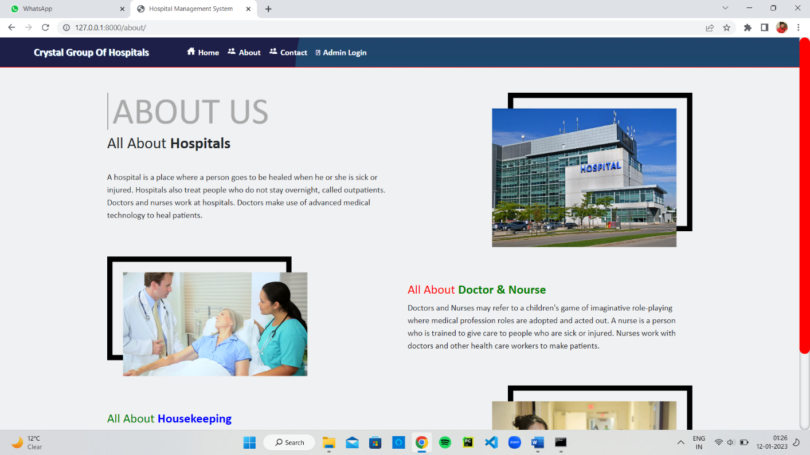

**13**

**Contact Page**

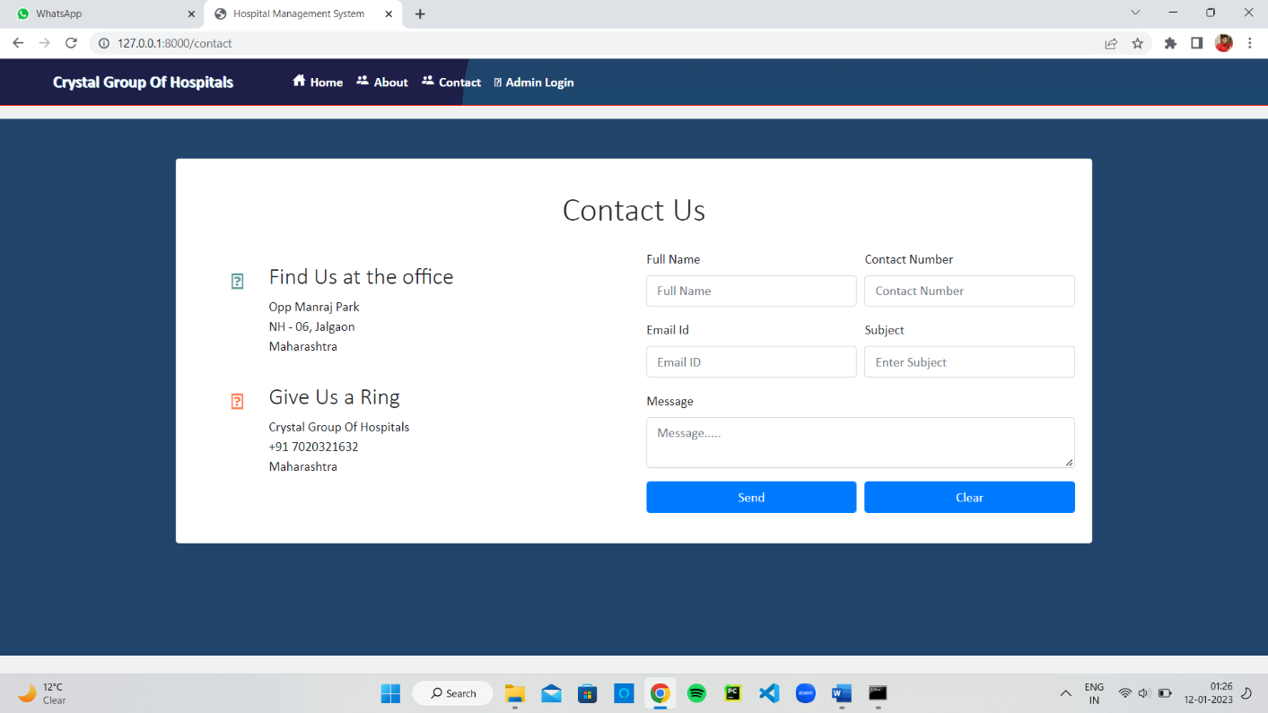

**Admin Login Page**

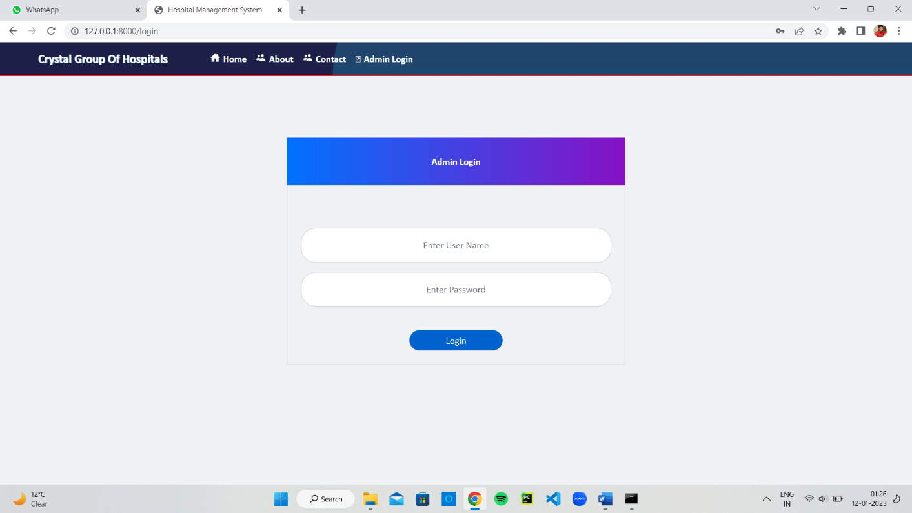

**14**

**Admin / Dashboard Page**

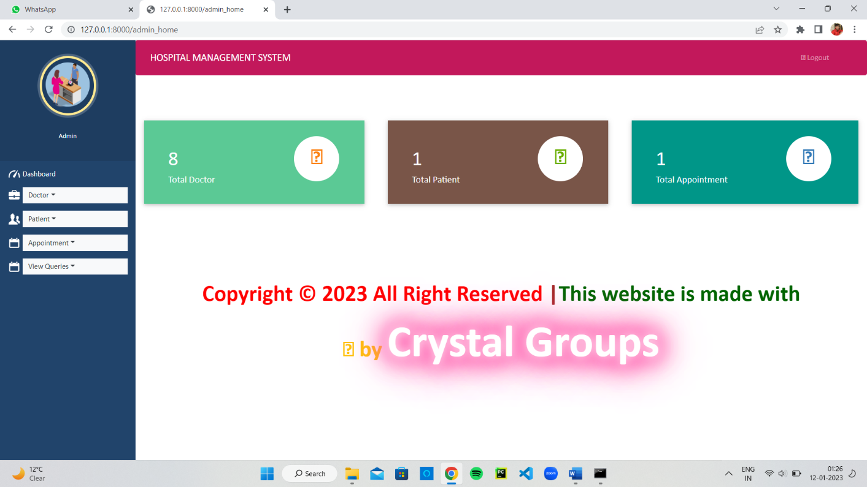

**Add / View Doctor Page**

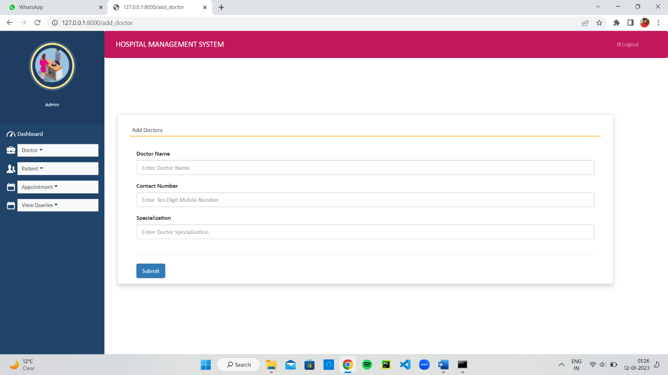

**15**

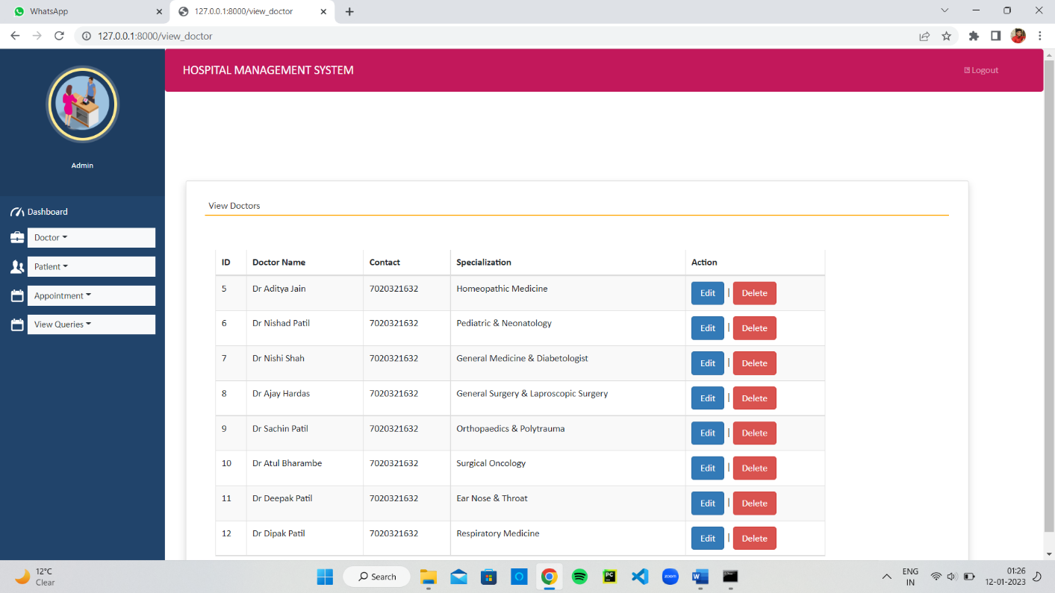

**Add / View Patients Page**

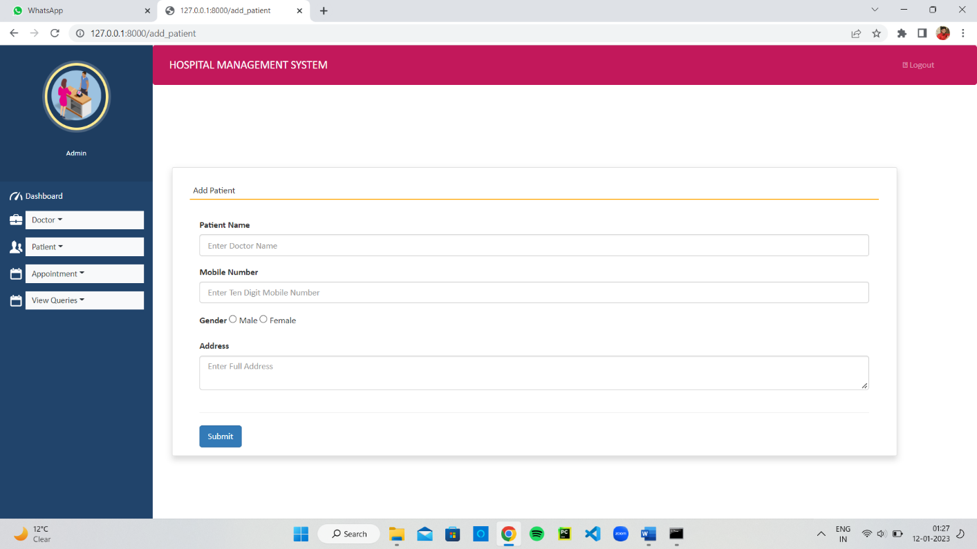

**16**

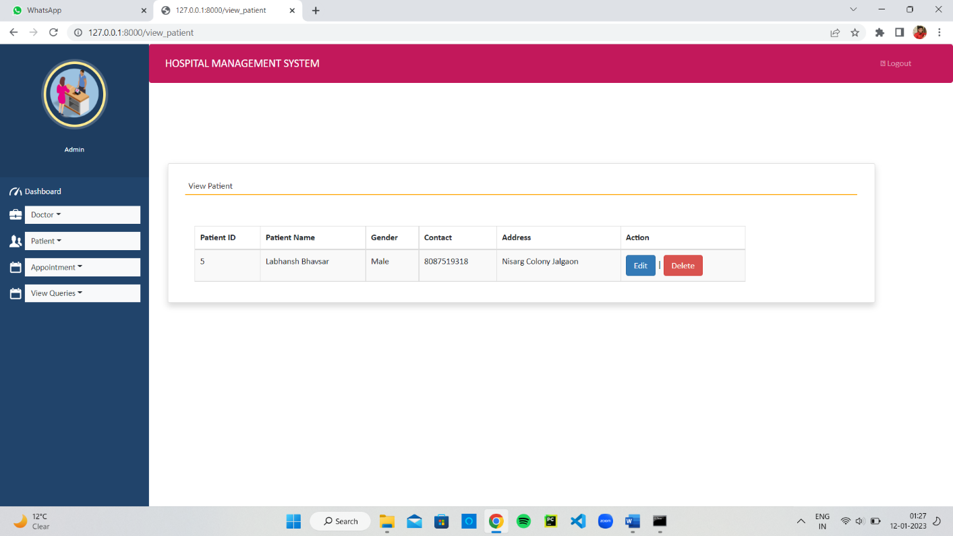

**Add / View Appointments Page**

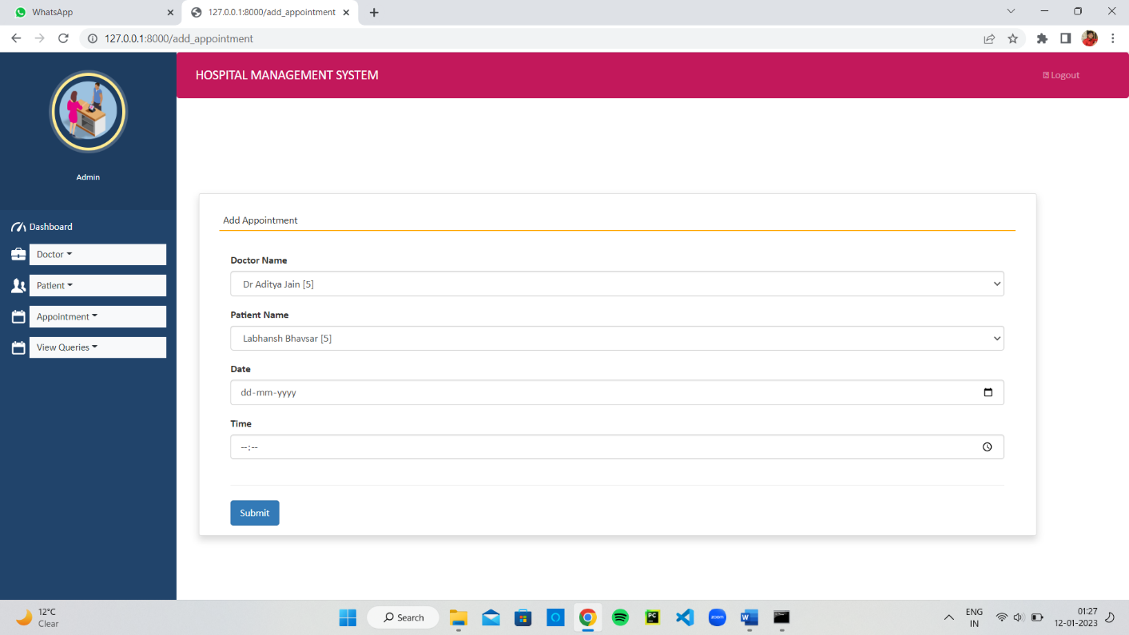

**17**

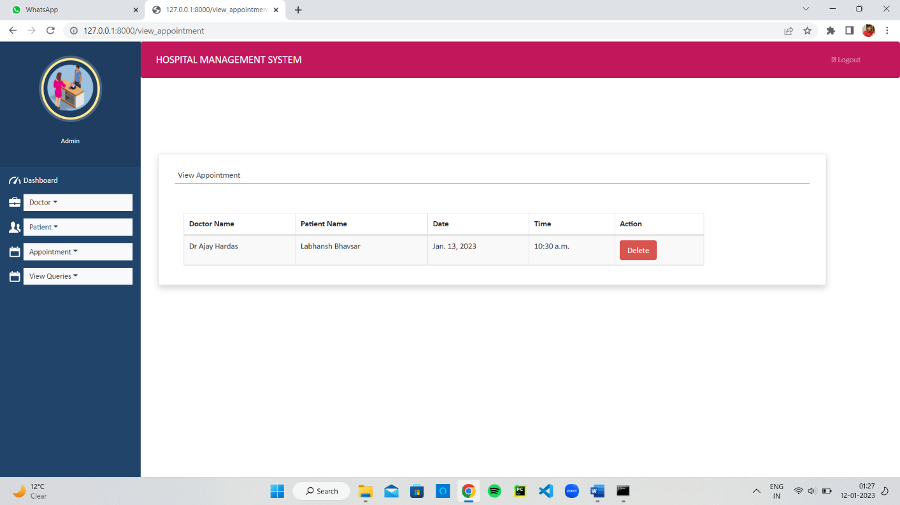

**Unread / Read Queries Page**

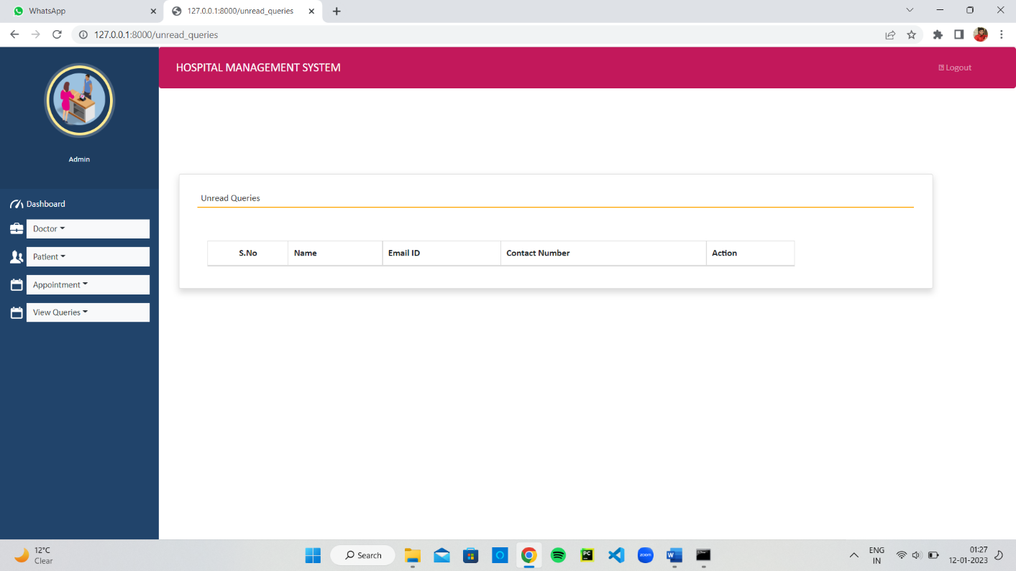

**18**

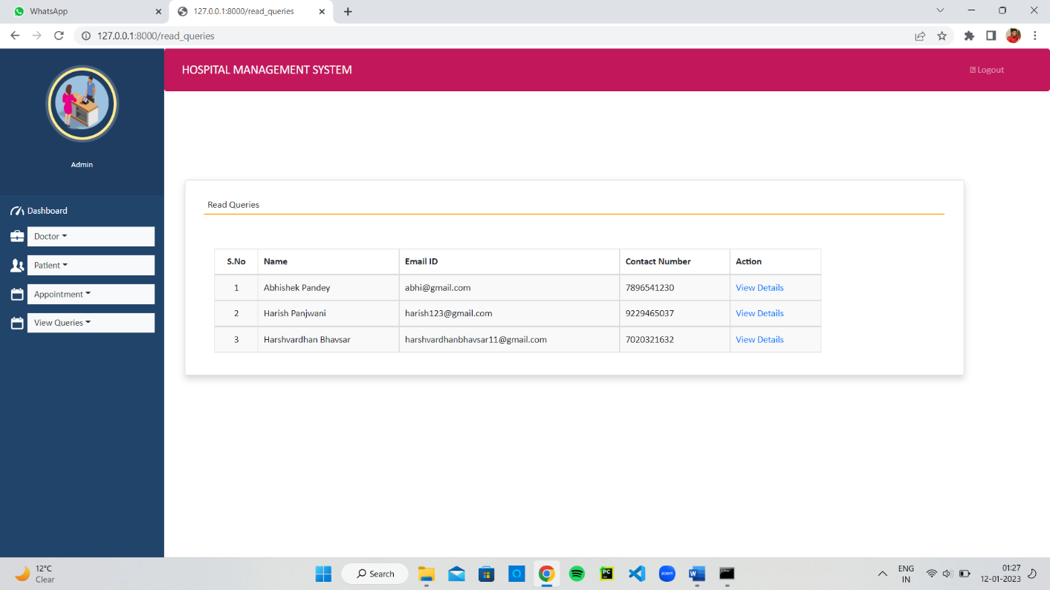

**19**

**LIMITATION**

* The existing system only provides text-based interface, which is not as user-friendly as Graphical user Interface
* Understanding flow of application is very hard one. It is little bit of complex to implement and not suitable for small level applications.

* Also apart from Clinic features, new features can be added in the system.
* Requires an active internet connection.
* Its deployment is little bit hard one.

**20**

**CONCLUSION**

1. The development of Clinic Management System involved many phases. The approach used is a top-down one concentrating on what first then how and moving to successive levels of details.
2. The first phase started with a detailed study of the problems and prospects of ordering in Foods
3. It provides a friendly graphical user interface which proves to be better

when compared to the existing system.

1. System security, data security and reliability are the striking features.
2. Updating of information becomes so easier.
3. We make a Clinic Management System which is easy better and quick for everyone.

**21**

**REFERENCES**

**Books:**

1. Core Python Programming
2. Data Structures and Algorithms in python
3. Django for Beginners
4. Django: Web Development with Python
5. Django RESTful Web Services

**Websites:**

1. [www.tutorialspoint.com](http://www.tutorialspoint.com/)
2. [www.w3schools.com](http://www.w3schools.com/)
3. [www.python.org](http://www.python.org)
4. [www.fullstackpython.com](http://www.fullstackpython.com)
5. www.realpython.com

**22**